CprE 381: Computer Organization and Assembly-Level Programming

Project Part 1 Report

Team Members: ___________Bailey Gorlewski______________________

___________Ian Johnson__________________________

__________Yohan Bopearatchy__________________

Project Teams Group #:__________Section 7 - Group 1_______________

Refer to the highlighted language in the project 1 instruction for the context of the following questions.

[Part 1 (d)] Include your final MIPS processor schematic in your lab report.
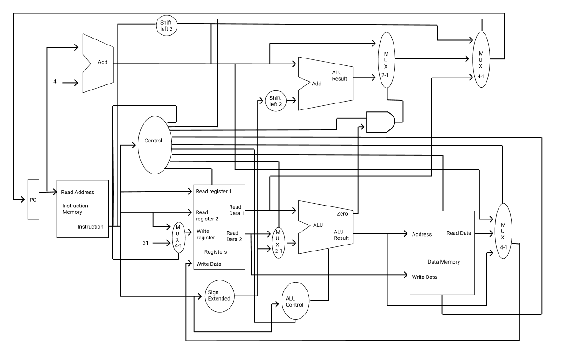
[Part 2 (a.i)] Create a spreadsheet detailing the list of M instructions to be supported in your project alongside their binary opcodes and funct fields, if applicable. Create a separate column for each binary bit. Inside this spreadsheet, create a new column for the N control signals needed by your datapath implementation. The end result should be an N*M table where each row corresponds to the output of the control logic module for a given instruction.

[Part 2 (a.ii)] Implement the control logic module using whatever method and coding style you prefer. Create a testbench to test this module individually, and show that your output matches the expected control signals from problem 1(a).
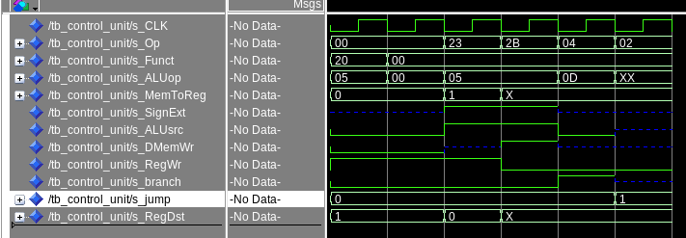
This is the testbench for our control logic unit, When putting in the opcode for a Add instruction(000000)(100000), I can see that the opcode is correctly set to 00101, memToReg is ‘0’ so it will take the ALUOut to write back to the register file. SignExt is undefined, because we are not taking an immediate value. ALUsrc is ‘0’, so it won’t take an immediate value. DmemWr is ‘0’ because we aren’t writing to dmem. RegWr is ‘1’ because we are writing back to the regFile. RegDest is “01” because we are taking rd as the RegFile write address. Checking the other instructions, our Control unit is working as expected.

[Part 2 (b.i)] What are the control flow possibilities that your instruction fetch logic must support? Describe these possibilities as a function of the different control flow-related instructions you are required to implement.

The control flow possibilities of our instruction fetch logic must be able to read from the instruction memory. It must also be able to update the PC values to be the address of the next instruction. The fetch control flow will not require a control signal, and will instead only use a clock signal.

[Part 2 (b.ii)] Draw a schematic for the instruction fetch logic and any other datapath modifications needed for control flow instructions. What additional control signals are needed?

[Part 2 (b.iii)] Implement your new instruction fetch logic using VHDL. Use Modelsim to test your design thoroughly to make sure it is working as expected. Describe how the execution of the control flow possibilities corresponds to the Modelsim waveforms in your writeup.

[Part 2 (c.i.1)] Describe the difference between logical (srl) and arithmetic (sra) shifts. Why does MIPS not have a sla instruction?
SRA preserve sign bit, perform multiplication and division, and is used for signed interpretation. SRL doesn’t preserve sign bit, only performs multiplication, and and is used for unsigned interpretation. SLA doesn’t exist because it would cause overflow.

[Part 2 (c.i.2)] In your writeup, briefly describe how your VHDL code implements both the arithmetic and logical shifting operations.
We have a mux that decides whether to use sra or srl .The signals are used to tie that mux to the correct barrel shift.

[Part 2 (c.i.3)] In your writeup, explain how the right barrel shifter above can be enhanced to also support left shifting operations.
If you flip the input bits before the barrel shift and flip the output after the barrel shift this would cause a barrel shift left using barrel shift right.

[Part 2 (c.i.4)] Describe how the execution of the different shifting operations corresponds to the Modelsim waveforms in your writeup.

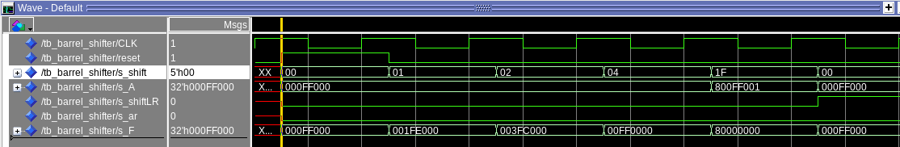

[Part 2 (c.ii.1)] In your writeup, briefly describe your design approach, including any resources you used to choose or implement the design. Include at least one design decision you had to make.

Additional functional units:
And Unit: This and unit, is a 32 bit and gate that computes a bit wise and on each bit. I used a base and gate for this, and made it applicable to 32 bits. I made the decision to have this component separate from any other, because It is easier for comprehension, but is not cost efficient.

Or Unit: This and unit, is a 32 bit or gate that computes a bit wise or on each bit. I used a base or gate for this, and made it applicable to 32 bits. I made the decision to have this component separate from any other, because It is used for the nor instruction.

Xor Unit: This and unit, is a 32 bit xor gate that computes a bit wise xor on each bit. I used a base xor gate for this, and made it applicable to 32 bits. I made the decision to have this component separate from any other because it is easier to understand and implement having different units coming together.

Repl Unit: This unit is a replication unit, that takes in an input byte, and replicates it through the whole output. I chose tho design this unit in a dataflow style, as it was much easier to concatenate the input bit several times.

Slt Unit: The Slt Unit takes in wheither it is a sltu or slt instruction, the output of the add/sub unit, the ALU inputs A and B, and outputs F. I designed this unit to be a help to computing the slt function. While not required I made this unit able to handle the sltu case, as it could be used to expand the functionality of the processor in the future. The slt unit outputs 1 if A<B otherwise 0.

[Part 2 (c.ii.2)] Describe how the execution of the different operations corresponds to the Modelsim waveforms in your writeup.

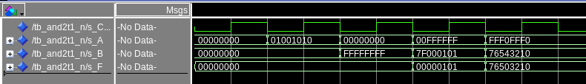
This is the waveform to test the and unit, We can see that the bits are only 1 when both bits in A and B are 1.
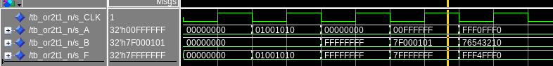
This is the waveform to test the or unit, We can see that the bits are 1 when any bit in A or B are 1.
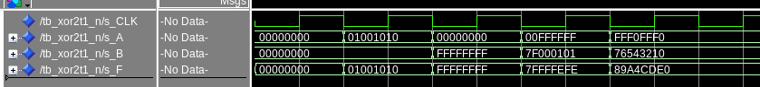
This is the waveform to test the xor unit, We can see that the bits are 0 when both bits in A and B are the same.
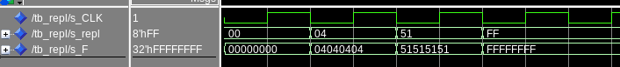
This is the tests, the Repl unit, As you can see the input bit is copied throughout the entire output.

[Part 2 (c.iii)] Draw a simplified, high-level schematic for the 32-bit ALU. Consider the following questions: how is Overflow calculated? How is Zero calculated?
How is slt implemented?
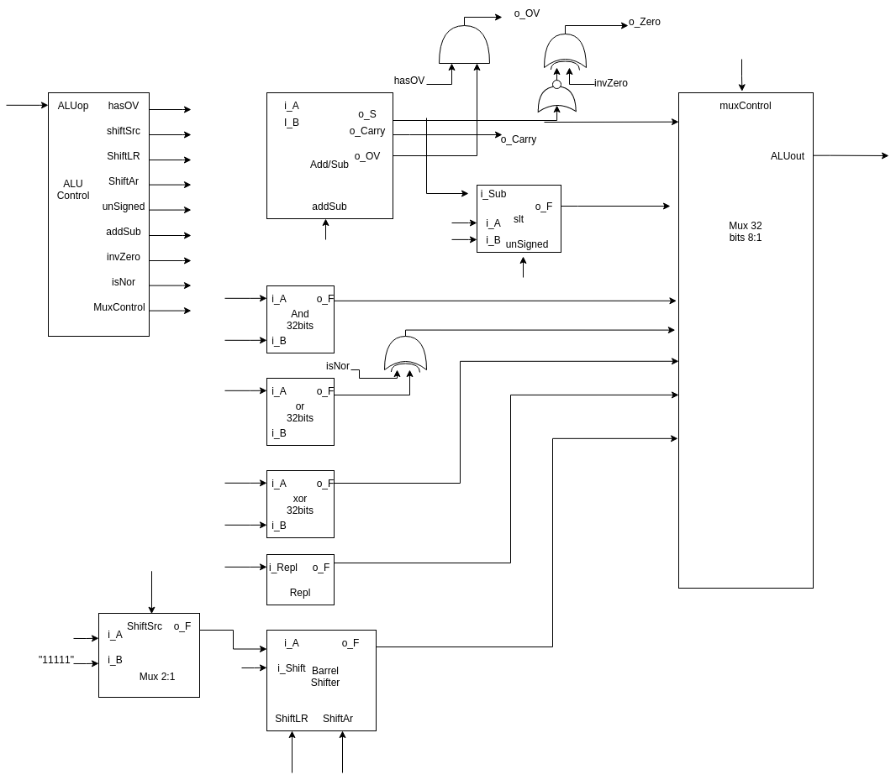
This is the simplified ALU. Overflow is calculated in the add/sub unit. This can be done by comparing the last carry bit and the second to last carry bit with an xor. Zero is calculated, by using a 32:1 or gate. This gate will turn on if any of its 32 input signals are 1. The output of the adder is passed in, bit to bit, and the output will be 0 if none of the bits are 1. Slt is implemented by doing a subtraction A-B. After the subtraction, you can look whether the number is positive or negative and return the corresponding result. For my implementation this was not good enough because I wanted it to accomplish the sltu instruction as well. Therefore the additional slt logic unit is used. If the subtraction is the result of a negative(neg) minus a positive(pos) (neg-pos) then the slt unit will always return a 0x00000000. This is flipped if the instruction is unsigned. Likewise for (pos – neg) it will always return 0x00000001. Again it is flipped in the unsigned case. For neg – neg, or pos – pos the sign of the subtraction is used. (neg) just means that the MSB is ‘1’.

[Part 2 (c.v)] Describe how the execution of the different operations corresponds to the Modelsim waveforms in your writeup.

Testing ALU with instructions:
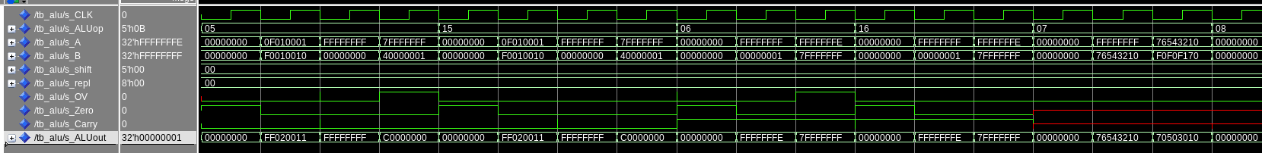
This screen-shot tests: the Add instruction, Addu, Sub, Subu, and And instructions.
The add/sub instructions are mapped to the Add/sub unit in the ALU, the ‘And’ instruction is mapped to the ‘And’ Unit. This is done by the MUX in the ALU.

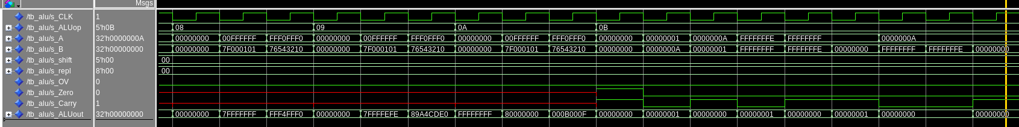
This screen-shot shows the tests for the OR, XOR, NOR, and most of the SLT instructions. The XOR instruction is mapped to its respected Unit, however the NOR instruction goes into an xor gate, which inverts the signal if the instruction is a nor. The SLTis thoroughly tested with positive and negative numbers. This is calculated using the add/sub unit and the slt logic unit.
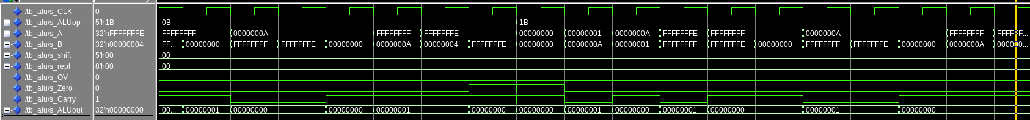
This screen-shot shows the tests for SLT and SLTU instruction, This is still calculated from the add/sub unit and slt logic unit. The final MUX in the ALU selects what output gets passed to the output of the ALU.
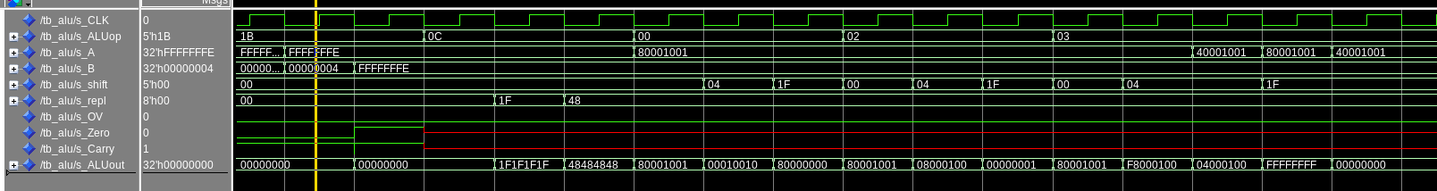
This screen-shot shows the tests for the repl, sll, srl, and sra instuctions. These instructions are mapped from the repl unit, and barrel shifter. Again the output of those units are selected at the end of the ALU with a MUX.
[Part 2 (c.viii)] justify why your test plan is comprehensive. Include waveforms that demonstrate your test programs functioning.

[Part 3] In your writeup, show the Modelsim output for each of the following tests, and provide a discussion of result correctness. It may be helpful to also annotate the waveforms directly.

[Part 3 (a)] Create a test application that makes use of every required arithmetic/logical instruction at least once. The application need not perform any particularly useful task, but it should demonstrate the full functionality of the processor (e.g., sequences of many instructions executed sequentially, 1 per cycle while data written into registers can be effectively retrieved and used by later instructions). Name this file Proj1_base_test.s.

[Part 3 (b)] Create and test an application which uses each of the required control-flow instructions and has a call depth of at least 5 (i.e., the number of activation records on the stack is at least 4). Name this file Proj1_cf_test.s.

[Part 3 (c)] Create and test an application that sorts an array with N elements using the BubbleSort algorithm (link). Name this file Proj1_bubblesort.s.

[Part 4] report the maximum frequency your processor can run at and determine what your critical path is. Draw this critical path on top of your top-level schematics. What components would you focus on to improve the frequency?

